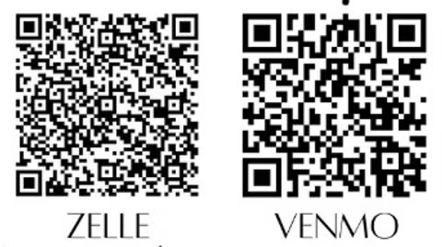
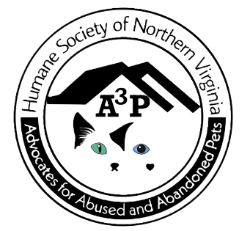

Please send this form and your donation to:
A3P
PO Box 36
Thornburg, VA 22565
All donations are tax deductible
EIN: 82-2554833

My bequest is in memory of:

Person: Connie Dallas
Pet: Georgia the cat
Message: Mom rescued Georgia from my veterinarian clinic. They called him parking lot kitty, because he was found abandoned in a parking lot. Then Yogi, because he stole my veterinarian’s yogurt she left sitting on a counter. Then Mom named him Georgie, because he came from Georgia. Georgie kept her company for the last ten years or so and they depended on each other.

Humane Society of Northern Virginia
powered by
Advocates for Abused and Abandoned Pets (A3P)
Tribute
Honor your family member, friend, or pet with a special donation in their name.
I am enclosing my gift donation of

$25___ $50___ $100___ $250___ Other $____

